**User Manual for Hotel Management**



**Session: 2021 – 2025**

**Submitted by:**

Saleem Malik(2021-CS-32)

Mustafa Riaz(2021-CS-39)

Abdur Rehman(2021-CS-44)

**Supervised by:**

Sir: Atif Warraich

Department of Computer Science

**University of Engineering and Technology Lahore Pakistan**

## Table of Contents

Contents

Table of Contents 1

1. Abstract 3

2 Introduction 3

2. Proposed System: 4

1. FEASIBILTY REPORT 4

1.1 PROBLEM IN THE CURRENT SYSTEM: 4

2. Technical Description 5

3. GRAPHICAL USER INTERFACE 5

3.1 Purpose: 5

3.2 Scope: 5

4. Project Design Description 6

5. Functional Requirements: 6

1. Scope of The Development Project: 6

1.1 Database Tier: 6

1.2 User Tier: 6

1.3 Data Base Connectivity Tier: 6

2. Software Requirement Specification 7

2.2 Required Software 7

3. Modules Description 7

3.1 ACCOMMODATION INFORMATION: 7

3.2 UNITS INFORMATION: 8

3.3 BOOKING MODULE: 8

3.4 GUEST MODULE: 8

3.5 FACILITIES MODULE: 8

4. NUMBER OF VIEWS: 8

4.1 Administrative View 8

1. Front end or User Interface Design 9

1. IDE 9

2 Data Flow Diagrams 9

1. SEQUENCE DIAGRAMS 13

2. Testing 14

3. Installation and project description 16

1. Conclusions And Recommendations 16

## Abstract

The system aims at the maintenance and management of the different Hotels that are available in the different parts of the world. It mainly takes care of the Hotel management at the core area of the database. The system provides the information regarding the different Hotels that are available and their status specific to availability. The guests can visit the site and register themselves with the required information that is expected by the system. Each registered guest can raise a request for the unit bookings. The Guests are scheduled with the information of the availability of the units for they have requested the time.

The total front end was dominated using HTML standards applied with the dynamism of PYQT5 server pages. The communicating client was designed using servlet and JSP’s. At all proper levels high care was taken to check that the system manages the date consistency with proper business validations. The database connectivity was planned using the Java Data Base Connectivity , the authorization and authorization was cross checked at all stages. The user level accessibility has been restricted into two zones the administrative and the normal user zone.

## Introduction

The entire project has been reimagined with a technology stack centered around PyQt5, Python, and SQL. Embracing the power of PyQt5, the user interfaces have been crafted to deliver an intuitive and responsive experience. Python serves as the backbone of the application, providing robust backend functionality and facilitating seamless integration between different components.

The specifications have been reworked and normalized up to 3NF, addressing potential anomalies arising from database transactions. SQL is employed for efficient database management, ensuring data integrity and reliability. The internal database has been transitioned to leverage the capabilities of SQL, optimizing table structures and queries for enhanced performance.

In this redesigned system, the focus remains on distributed client-server computing, and browser-specific interfaces have been replaced with PyQt5-based interfaces, enabling cross-platform accessibility. The chosen database technology is SQL, reinforcing the system's commitment to data consistency and reliability. User-level accessibility is maintained with distinct zones for administrative and normal users, and proper business validations are seamlessly integrated into the Python backend. The revised technology stack, featuring PyQt5, Python, and SQL, ensures a modern, efficient, and secure foundation for the entire application.

3

## Proposed System:

The Automated system with distributed architecture can support issues like.

1. The system maintains the different location that are available and registered in a central DB, which leads easy accessibility and consistency.
2. Each Accommodation available units and all the unit facilities are also available at the click of a mouse.
3. The Units can be booked by the Registered guest irrespective of the Geographical barriers.
4. The Guest are provided with up to minute information related to the unit availability and their status. From their convenient place.
5. The decision process in more faster and more consistent.
6. The guest have information at their demand related to any unit status of their own unit booking status.

# FEASIBILTY REPORT

* 1. **GENERAL REQUIREMENTS FEASIBILTY REPORT:**
* The new system should be cost effective
* To improve productivity and service and service.
* To enhance user interface.
* To improve information presentation and durability.
* To upgrade systems reliability, availability and flexibility.
* To address human factors for better and uses acceptance.

# PROBLEM IN THE CURRENT SYSTEM:

The present system is presently is an undeveloped form and the manual process of the overall system is too clumsy and complicated. The clients in the real time consultancy system can be too thick and may need many resources to be used upon the system. If the system is developed, in a distributed over interface with centralized database is the only solution.

## Technical Description

The total number of databases that were identified to build the system is 10. The major part of the Databases is categorized as Administrative components and the user components.

The administrative components are useful is managing the actual master data that may; be necessary to maintain the consistency of the system. The administrative databases are purely used for the internal organizational needs and necessities.

The user components are designed to handle the transactional state that arise upon the system whenever the general client makes a visit onto the system for the sake of the report based information.

The user components are scheduled to accept parametrical information for the user as per the systems necessity.

# GRAPHICAL USER INTERFACE

For the flexibility of the user, the interface has been developed in graphical user interface with modern style of the GUI in Qt Designer .

The GUI’s at the top level has been categorized as:

1. Administrative user interface
2. Customer or general user interface

The administrative user interface concentrates on the consistent information that is practically, pact of the organizational activities and which needs proper authentication for the data collection. The interfaces help the visitors with all the transactional states like Data insertion, Data deletion and Data updating with the data search capabilities.

The general user interface helps the users upon the system in transactions through the required services that are provided upon the system. The general user interface also helps the ordinary user is managing their own information in a customized manner as per their flexibilities.

## Purpose:

The main purpose for preparing this document is to give a general insight into the analysis and requirements of the existing system or situation and for determining the operating characteristics of the system.

## Scope:

This Document plays a vital role in the development life cycle (SDLC) As it describes the complete requirement of the system. It is meant for use by the developers and will be the

## Project Design Description

basic during testing phase. Any changes made to the requirements in the future will have to go through formal change approval process.

## 5. Functional Requirements:

Inputs:

The major inputs for Integration of Data Is from the local Desktop and System can be categorized module -wise.

Basically all the information is managed by the software and in order to access the information one has to produce one's identity by entering the user-id and password.

Every user has their own domain of access beyond which the access is dynamically refrained rather denied.

Output:

The major outputs of the system are tables and reports. Tables are created dynamically to meet the requirements on demand.

Reports, as it is obvious ,carry the gist of the whole information that flows across the institution. This application must be able to produce output at different modules for different inputs.

## Scope of The Development Project:

## Database Tier:

As We Now SQL is taken as the standard query language. The overall business rules are designed by using the power of SQL components like stored procedures stored functions and database triggers.

## User Tier:

The use interface is developed is a PYQT specific environment to have distributed architecture.

## Data Base Connectivity Tier:

The communication architecture is designed by concentrated on the standards of servlets and JSP’s. The database connectivity is established using the Python Database connectivity

## Software Requirement Specification

* 1. **Required Hardware**
     + Pentium IV Processor.
     + 512 MB RAM.
     + 20 GB Hard Disk space.
     + Ethernet card with an Internet and Internet zone**.**

## Required Software

* + - Windows 10 operating system.
    - Internet explorer11 and Netscape navigator.
    - MYSQL
    - TCP/IP Protocol suite.

## Modules Description

Number of Modules:

* Accommodation Information Module
* Units Information Module.
* Bookings Information Module.
* Guests Information Module.
* Facilities Information Module.

# ACCOMMODATION INFORMATION:

This module maintains all the details of the Accommodation location that are available and the units that are available under each location along with their reference unit types.

# UNITS INFORMATION:

This module maintains the information regarding all the units that are registered as per specifications and their reference unit types. The module also takes care of the system from the unit facilities and reference unit facilities that are available.

# BOOKING MODULE:

This module maintains the information of all the booking of the units, as pet the guest requirements, it searches itself with the units station database and the specific registered guest who have raised the demand upon the booking.

# GUEST MODULE:

This module maintains the overall activities through which a guest is uniquely registered is the domain the module interpreter with the specific gender status and also centrally sets with interpretation through booking and registry to unit status.

# FACILITIES MODULE:

This module maintains the overall activities in the facilities that are available are provided fn all or some of the specified units. This module helps in registering the reference unit facilities that may creep in into the system from time to time.

# NUMBER OF VIEWS:

* Administrative View (Admin)
* Guest View As (User)

## Administrative View

This view is designed for interacting with the absolute Meta Data, which becomes the ultimate repository to maintain the consistency.

This view is accessible only to registered administrators who are recognized by the Watershed Development central Administration Departmen

## Front end or User Interface Design

The entire user interface is planned to be developed in Desktop specific environment with a touch of Intranet-Based Architecture for achieving the Distributed Concept.

The Desktop specific components are designed by using the PYQT5 and QT Designer.

## IDE

## Visual Studio Code (VS Code) stands out as my preferred choice for Python projects due to its user-friendly interface, offering an intuitive and efficient development environment. The extensive library of Python-specific extensions enriches the coding experience, providing support for various tools and frameworks. That’s why I used the Vs code for the my Project

Provides an indication of how date is transformed as it moves through the system.

Disputes the functions and sub functions that transforms the dataflow.

## Data Flow Diagrams

**Admin**

**Units Info**

**Accommodation Info**

**Dashboard**

**Booking Info**

**ACCOMODATION**

**Guests**

**UPHOLDING SYS**

**Facilities Info**

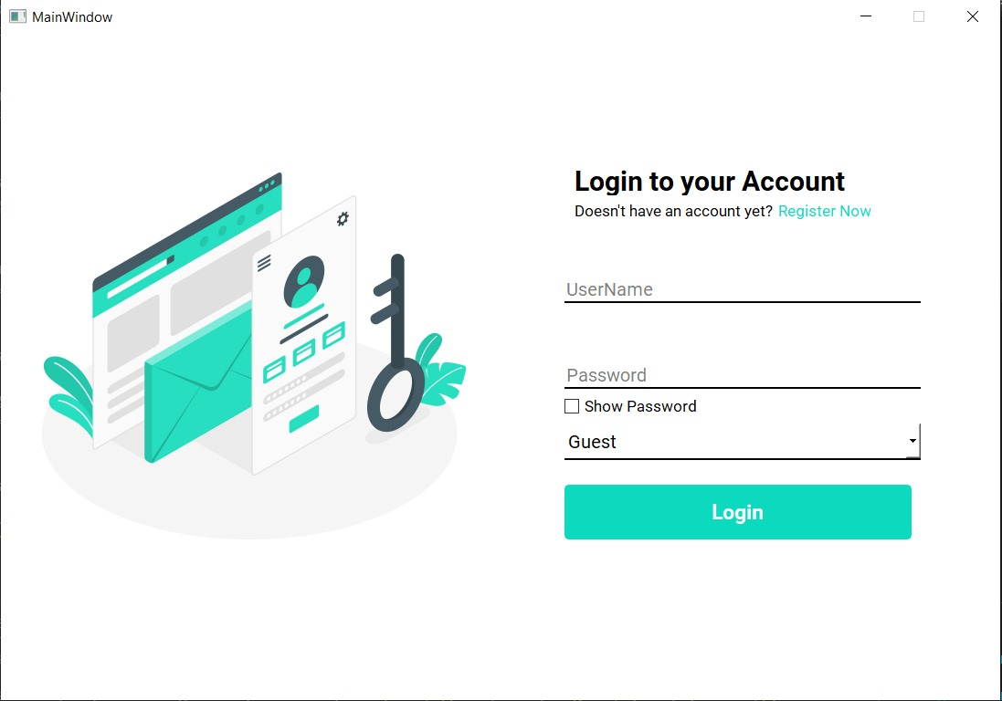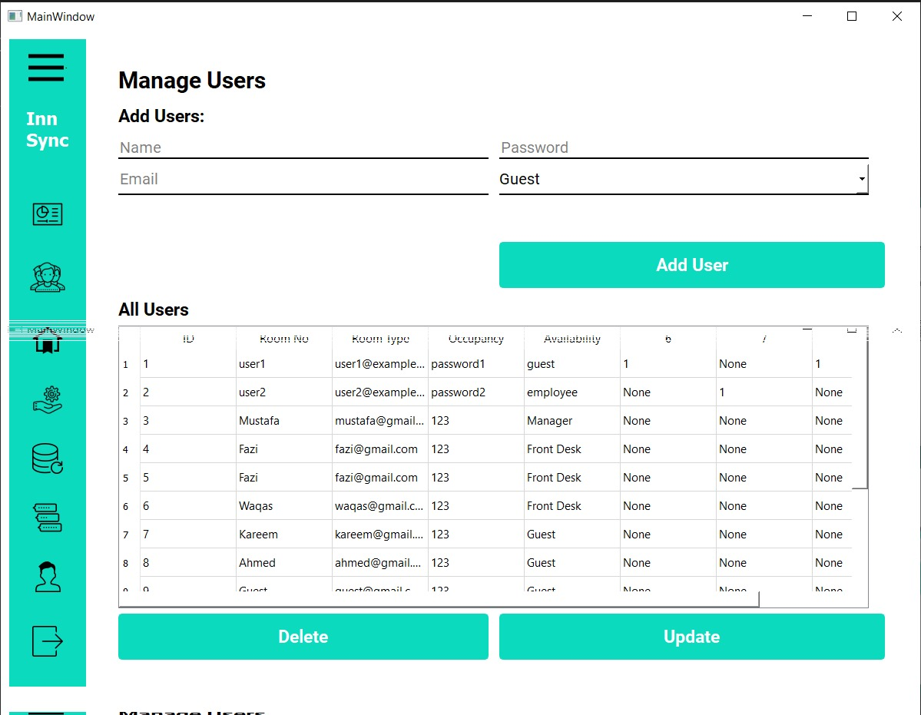**GUI**

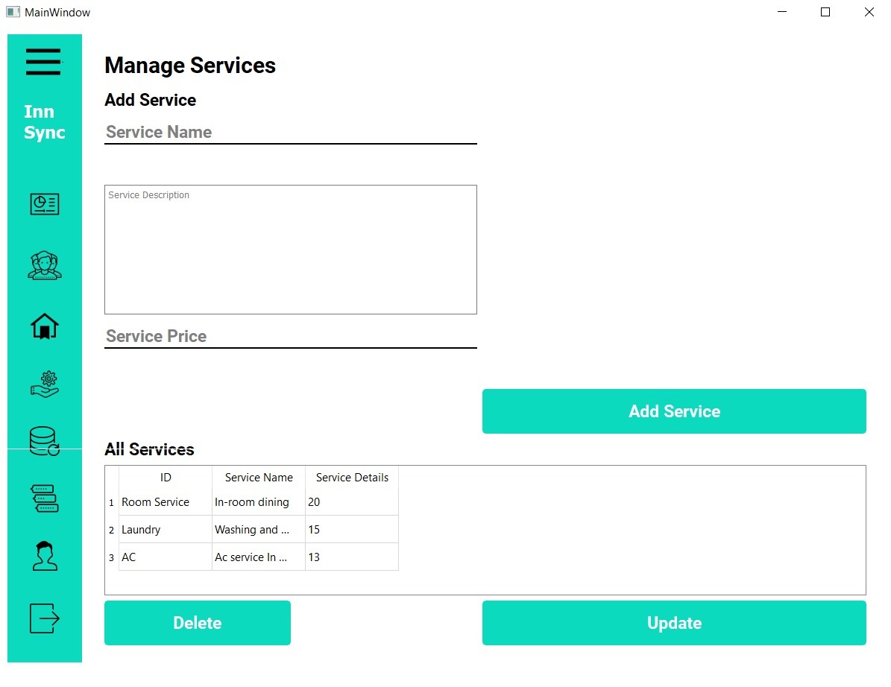

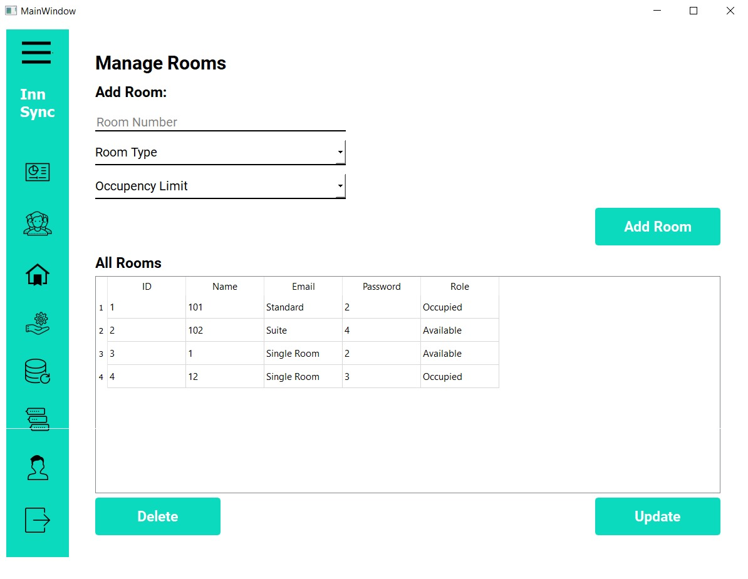

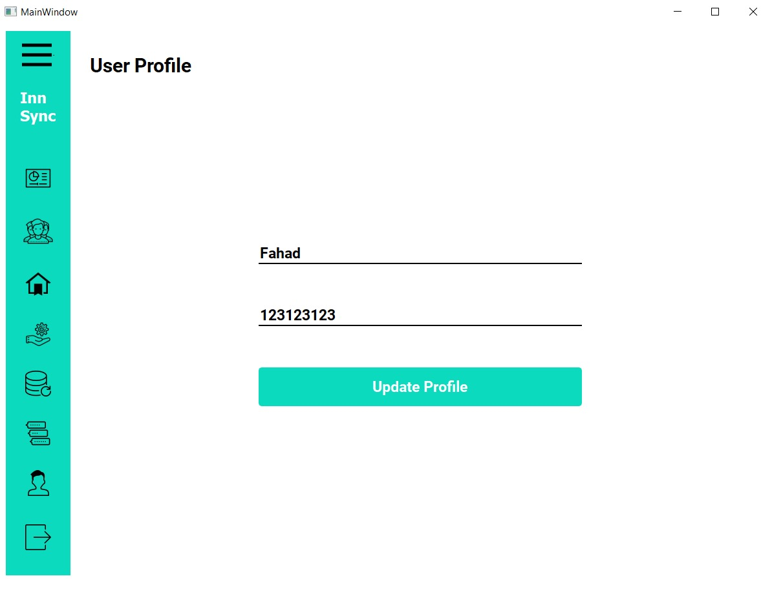 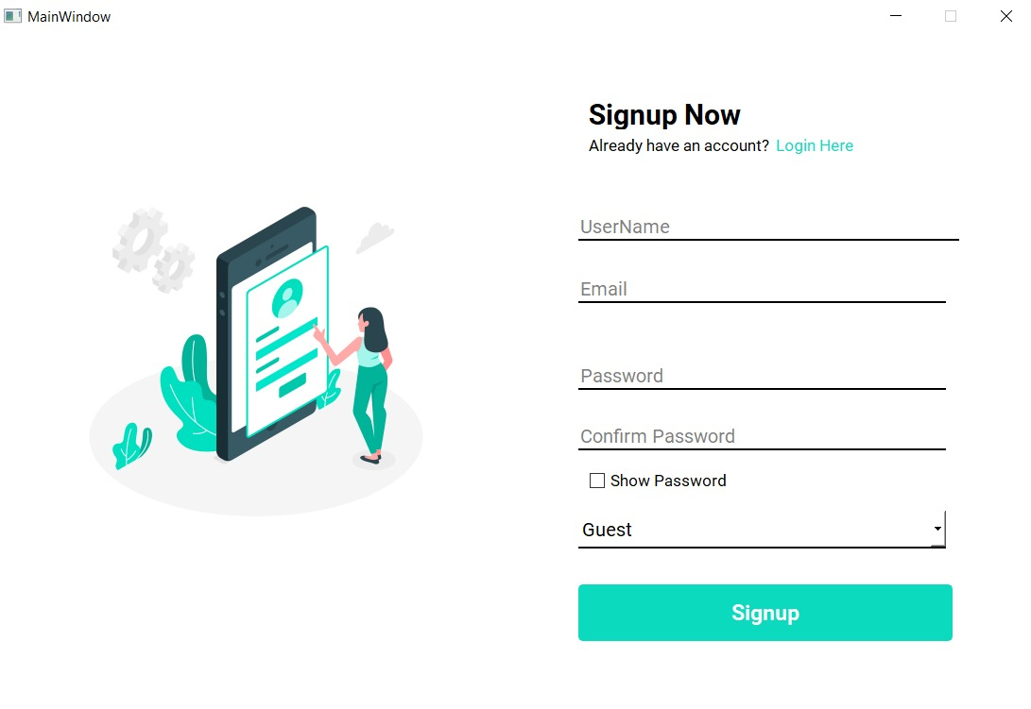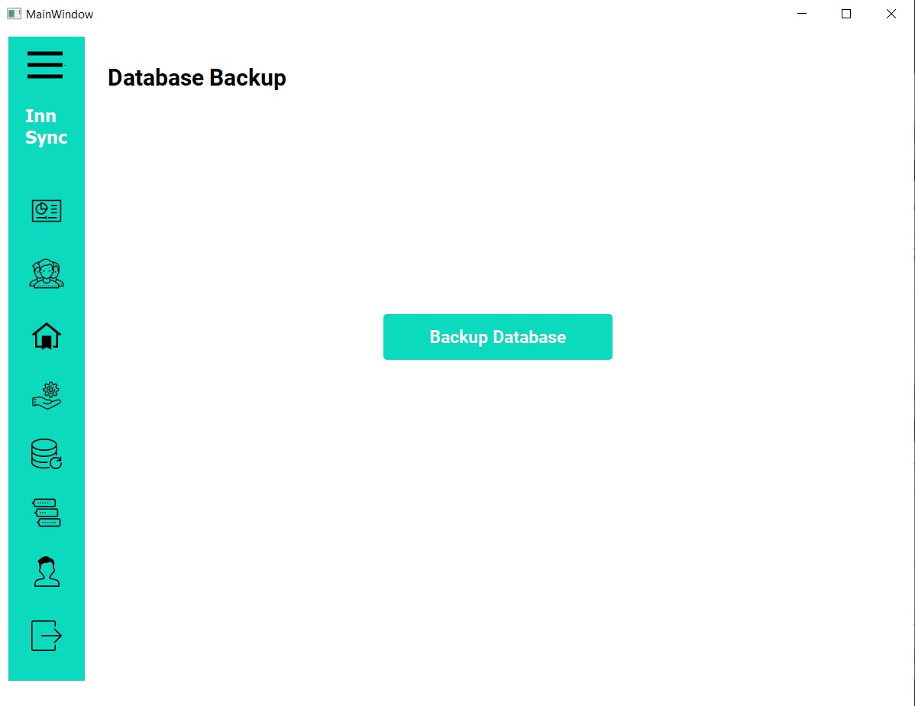

# SEQUENCE DIAGRAMS

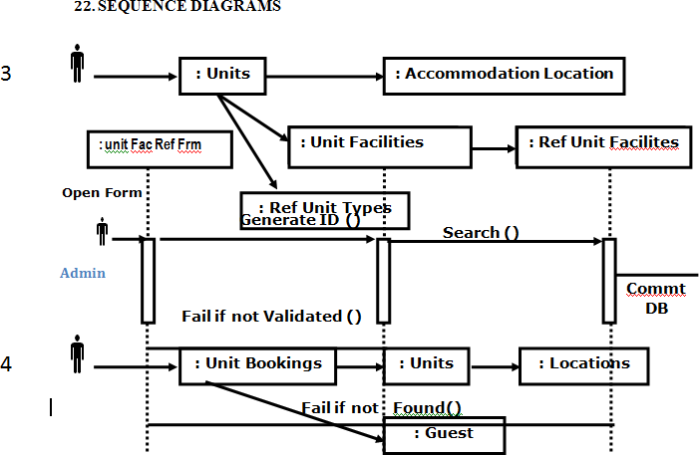

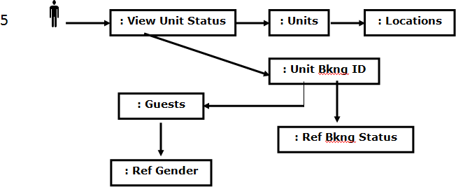

## Testing

Testing is the process of detecting errors. Testing performs a very critical role for quality assurance and for ensuring the reliability of software. The results of testing are used later on during maintenance also.

Psychology of Testing :

The aim of testing is often to demonstrate that a program works by showing that it has no errors. The basic purpose of testing phase is to detect the errors that may be present in the program. Hence one should not start testing with the intent of showing that a program works, but the intent should be to show that a program doesn’t work. Testing is the process of executing a program with the intent of finding errors.

Testing Objectives:

The main objective of testing is to uncover a host of errors, systematically and with minimum effort and time. Stating formally, we can say

* Testing is a process of executing a program with the intent of finding an error.
* A successful test is one that uncovers an as yet undiscovered error.
* A good test case is one that has a high probability of finding error, if it exists.
* The tests are inadequate to detect possibly present errors.
* The software more or less confirms to the quality and reliable standards.

Levels of Testing:

In order to uncover the errors present in different phases we have the concept of levels of testing. The basic levels of testing are as shown below…

Client Needs

Requirements

Design

Code

Acceptance Testing

System Testing

Integration Testing

Unit Testin

## Installation and project description

The database as it is developed by oracle 11g can be installed only by using the export and import concepts. Using core java and components like JSP and Servlets needs proper deployment as per general specifications developed the front end as it.The project can be described by the screenshots in the project as follows The following screenshots appear when the admin login to the browser.

## Conclusions And Recommendations

The entire project has been developed and deployed as per the requirements stated by the user, it is found to be bug free as per the testing standards that are implemented. Any specification untraced errors will be concentrated in the coming versions, which are planned to be developed in near future.The system at present does not take care of the money payment methods, as the consolidated constructs need SSL standards and are critically to be initiated in the first face, the application of the credit card transactions is applied as a developmental phase in the coming days. The system needs more elaborative technicality for its inception and evolution.